LAMPIRAN

**Lampiran A**

Sesuai dengan rujukan refrensi yang diperoleh (Incroperra & Osizik, 1996 dan Media Mesin, 2008), berikut adalah perhitungan panjang koil kondensor:

 (Tabel B-2, Osizik).













 ${\text{C}}_{\text{pc,f}}\text{ = 4,1889x}{\text{10}}^{\text{3}}$ ${\text{J}}/{\text{Kg.K}}$

${\text{μ}}_{\text{c}}\text{ = 410,7x}{\text{10}}^{\text{-6}}\text{ N.}{\text{s}}/{{\text{m}}^{\text{2}}}$

${\text{k}}_{\text{c}}\text{ = 0,6624} {\text{W}}/{\text{m.K}}$

${\text{P}}_{\text{rc,f}}\text{ =} \text{2,597}$

${\dot{\text{m}}}_{\text{c }}{\text{C}}_{\text{pc,f}} \left({\text{T}}_{\text{c,o}}\text{- }{\text{T}}_{\text{c,i}} \right)\text{ = }{\dot{\text{m}}}_{\text{h }}{\text{C}}_{\text{ph,g}} \left({\text{T}}_{\text{h,i}}\text{- }{\text{T}}_{\text{h,o}} \right)$

${\text{C}}_{\text{min}}\text{ = }{\text{C}}_{\text{h}}$

${\text{C}}_{\text{max}}\text{ = }{\text{C}}_{\text{c}}$

${{\text{C}}_{\text{h}}\text{<C}}_{\text{c}}\text{ ; }{\text{q}}_{\text{max}}\text{= }{\text{C}}_{\text{c}} \left({\text{T}}_{\text{h,i}}\text{- }{\text{T}}_{\text{c,i}} \right)\text{=120 }{\text{W}}/{\text{K}}\left(\text{150-27}\right)\text{K}$ $\text{=14760 W}$

$\text{q} \text{= ε.}{\text{q}}_{\text{max}}\text{= 0,975}.$ $\text{14760 W=14391 W ; }$

(Tabel B-2, Osizik).











${\text{C}}_{\text{ph,g}}\text{ = 4,2066x}{\text{10}}^{\text{3}}$ ${\text{J}}/{\text{Kg.K}}$

${\text{μ}}_{\text{h}}\text{ = 313,2x}{\text{10}}^{\text{-6}}\text{ N.}{\text{s}}/{{\text{m}}^{\text{2}}}$

${\text{k}}_{\text{h}}\text{ = 0,6758 }{\text{W}}/{\text{m.K}}$

${\text{P}}_{\text{rh,g}}\text{ =} \text{1,954}$

= 

(D = diameter *tube* 





**Lampiran B**

Menentukan Kadar (Rendemen) Minyak

$$\text{Rendemen} \text{Minyak} \left(\text{\%}\right)\text{=} \frac{\text{Massa Minyak (gr)}}{\text{Massa Bahan Baku (gr)}}\text{ x 100\%}$$

**(SNI 06-3735-1995)**

Perhitungan rendemen minyak atsiri terbanyak:

$$\text{Rendemen}\text{=}\frac{\text{berat} \text{minyak} \text{daun} \text{manis}}{\text{berat daun manis}}\text{ ×100\%}$$

$$= \frac{\text{12.29}\text{ gram}}{\text{ 750 gram}}\text{ ×100\%}$$

$$\text{= 1.6387 \%}$$

$$\text{Rendemen}\text{=}\frac{\text{berat} \text{minyak} \text{serbuk} \text{kayu} \text{manis}}{\text{berat} \text{serbuk} \text{kayu} \text{mani}}\text{ ×100\%}$$

$$\text{= }\frac{\text{11.22}\text{ gram}}{\text{ 750 gram}}\text{ ×100\%}$$

$$\text{= 1.496 \%}$$

$$\text{Rendemen}\text{=}\frac{\text{berat} \text{minyak} \text{kikisan} \text{kulit}\text{ kayu manis}}{\text{kikisan kulit kayu manis}}\text{ ×100\%}$$

$$\text{= }\frac{\text{10.719}\text{ gram}}{\text{ 750 gram}}\text{ ×100\%}$$

$$\text{= 1.4292 \%}$$

**Lampiran C**

Data hasil Penyulingan Limbah kulit kayu manis pasca panen

Tabel 1. Daun Kayu Manis

|  |  |  |  |  |  |
| --- | --- | --- | --- | --- | --- |
| No. | Takanan (P=atm) | Massa (gr) | Waktu (jam) | Massa (gr) | Rendemen (%) |
| 1 | 1.85 | 250 | 1 | − | − |
|  |  |  | 2 | 0.75 | 0.3 |
|  |  |  | 3 | 1.06 | 0.424 |
| 2 | 1.85 | 500 | 1 | 0.09 | 0.018 |
|  |  |  | 2 | 1.74 | 0.348 |
|  |  |  | 3 | 6.92 | 1.384 |
| 3 | 1.85 | 750 | 1 | 2.32 | 0.3093 |
|  |  |  | 2 | 5.67 | 0.756 |
|  |  |  | 3 | 12.29 | 1.6387 |
| 4 | 1.65 | 250 | 1 | 0.08 | 0.032 |
|  |  |  | 2 | 1.6 | 0.64 |
|  |  |  | 3 | 2.92 | 1.168 |
| 5 | 1.65 | 500 | 1 | 1.05 | 0.21 |
|  |  |  | 2 | 4.14 | 0.828 |
|  |  |  | 3 | 8.01 | 1.602 |
| 6 | 1.65 | 750 | 1 | − | − |
|  |  |  | 2 | 0.71 | 0.0946 |
|  |  |  | 3 | 5.68 | 0.7573 |
| 7 | 1 | 250 | 1 | 0.281 | 0.1124 |
|  |  |  | 2 | 1.902 | 0.7608 |
|  |  |  | 3 | 3.033 | 1.2132 |
| 8 | 1 | 500 | 1 | 0.02 | 0.004 |
|  |  |  | 2 | 1.351 | 0.2702 |
|  |  |  | 3 | 3.402 | 0.6804 |
| 9 | 1 | 750 | 1 | − | − |
|  |  |  | 2 | 0.58 | 0.0773 |
|  |  |  | 3 | 4.95 | 0.66 |

Tabel 2. Kikisan Kulit Kayu Manis

|  |  |  |  |  |  |
| --- | --- | --- | --- | --- | --- |
| No. | Takanan (P=atm) | Massa (gr) | Waktu (jam) | Massa (gr) | Rendemen (%) |
| 1 | 1.85 | 250 | 1 | 0.02 | 0.008 |
|  |  |  | 2 | 0.08 | 0.032 |
|  |  |  | 3 | 2.06 | 0.824 |
| 2 | 1.85 | 500 | 1 | 0.7 | 0.14 |
|  |  |  | 2 | 2.71 | 0.542 |
|  |  |  | 3 | 6.29 | 1.258 |
| 3 | 1.85 | 750 | 1 | 2.7 | 0.36 |
|  |  |  | 2 | 6.42 | 0.856 |
|  |  |  | 3 | 10.719 | 1.4292 |
| 4 | 1.65 | 250 | 1 | − | − |
|  |  |  | 2 | 0.07 | 0.028 |
|  |  |  | 3 | 1.41 | 0.564 |
| 5 | 1.65 | 500 | 1 | − | ­− |
|  |  |  | 2 | 1.34 | 0.268 |
|  |  |  | 3 | 4,14 | 0.828 |
| 6 | 1.65 | 750 | 1 | 0.189 | 0.126 |
|  |  |  | 2 | 4.08 | 0.544 |
|  |  |  | 3 | 7.670 | 1.0227 |
| 7 | 1 | 250 | 1 | − | − |
|  |  |  | 2 | − | − |
|  |  |  | 3 | 0.01 | 0.004 |
| 8 | 1 | 500 | 1 | − | − |
|  |  |  | 2 | 0.011 | 0.0022 |
|  |  |  | 3 | 0.472 | 0.0944 |
| 9 | 1 | 750 | 1 | − | − |
|  |  |  | 2 | 0.17025 | 0.0227 |
|  |  |  | 3 | 1.905 | 0.254 |

Tabel 3. Serbuk Limbah Kayu Manis

|  |  |  |  |  |  |
| --- | --- | --- | --- | --- | --- |
| No. | Takanan (P=atm) | Massa (gr) | Waktu (jam) | Massa (gr) | Rendemen (%) |
| 1 | 1.85 | 250 | 1 | 0.15 | 0.06 |
|  |  |  | 2 | 0.28 | 0.112 |
|  |  |  | 3 | 0.99 | 0.396 |
| 2 | 1.85 | 500 | 1 | 1.43 | 0.286 |
|  |  |  | 2 | 4.55 | 0.91 |
|  |  |  | 3 | 6.84 | 1.368 |
| 3 | 1.85 | 750 | 1 | 2.97 | 0.396 |
|  |  |  | 2 | 7.7025 | 1.027 |
|  |  |  | 3 | 11.22 | 1.496 |
| 4 | 1.65 | 250 | 1 | 0.121 | 0.0484 |
|  |  |  | 2 | 0.2 | 0.08 |
|  |  |  | 3 | 0.791 | 0.3164 |
| 5 | 1.65 | 500 | 1 | 0.43 | 0.086 |
|  |  |  | 2 | 2.69 | 0.538 |
|  |  |  | 3 | 5.01 | 1.002 |
| 6 | 1.65 | 750 | 1 | 1.95 | 0.26 |
|  |  |  | 2 | 6.7215 | 0.8962 |
|  |  |  | 3 | 9.855 | 1.314 |
| 7 | 1 | 250 | 1 | − | − |
|  |  |  | 2 | 0.01 | 0.004 |
|  |  |  | 3 | 0.05 | 0.02 |
| 8 | 1 | 500 | 1 | 0.3196 | 0.0792 |
|  |  |  | 2 | 1.129 | 0.2258 |
|  |  |  | 3 | 1.45 | 0.29 |
| 9 | 1 | 750 | 1 | 0.99 | 0.132 |
|  |  |  | 2 | 3.2125 | 0.4283 |
|  |  |  | 3 | 4.329 | 0.5772 |

**Lampiran D**

Foto Hasil Pengujian

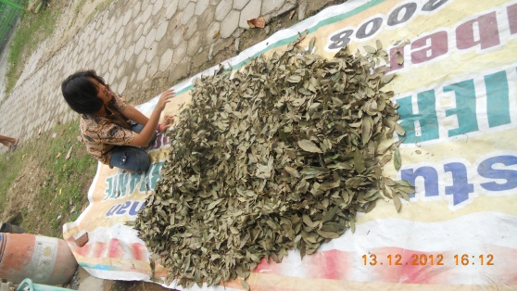 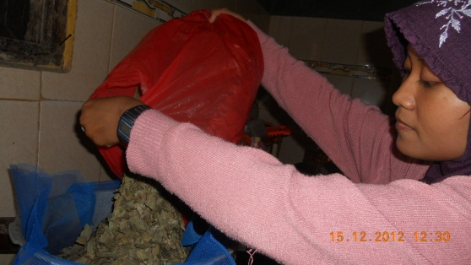

**Gambar 1.** Proses penjemuran **Gambar 2.** Pengisian bahan baku

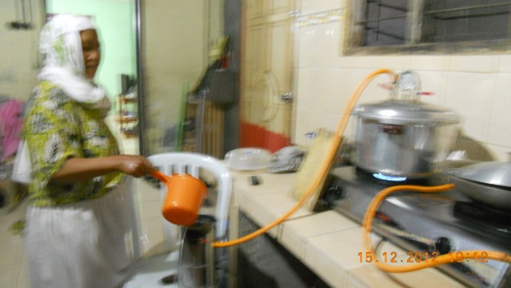 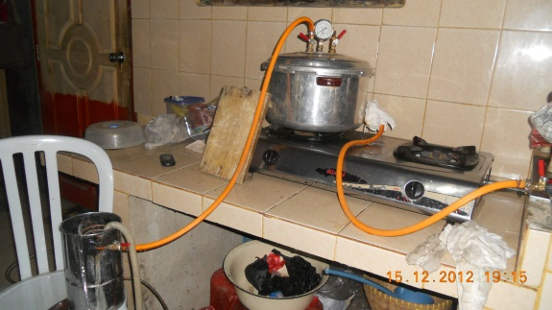

**Gambar 3**. Proses penyulingan

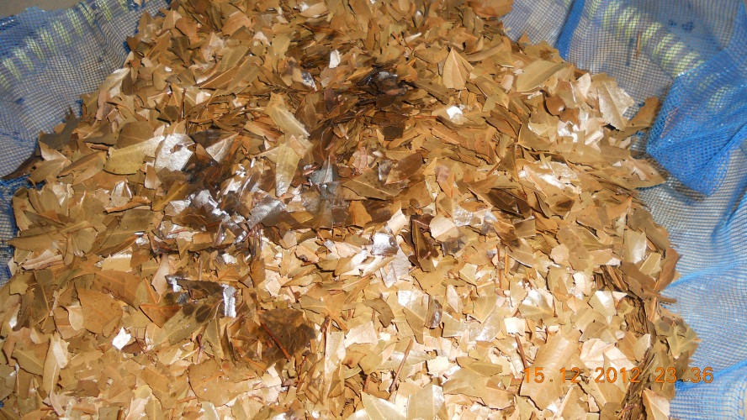

**Gambar 4.** Daun hasil penyulingan

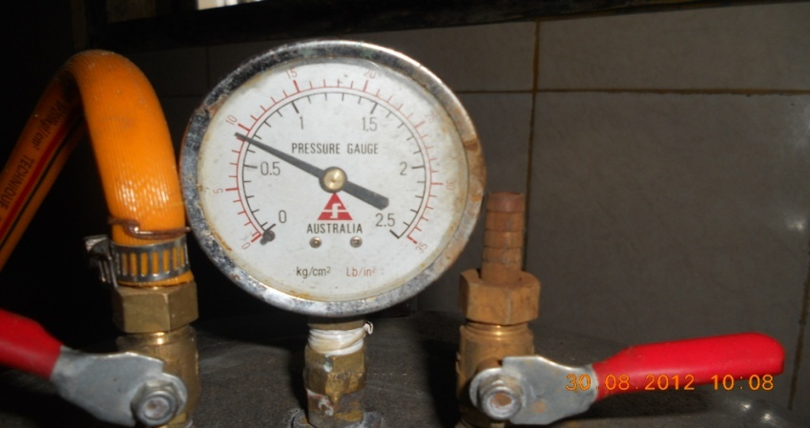 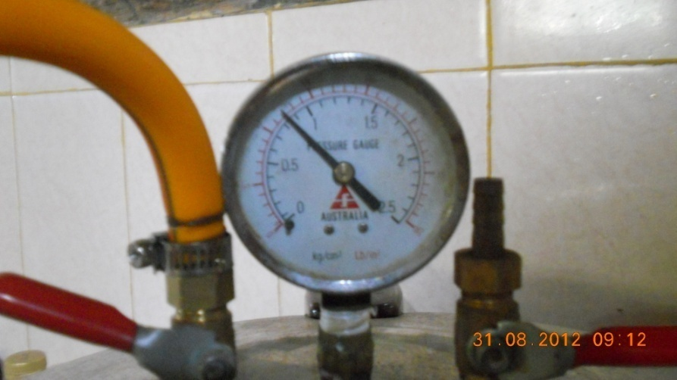 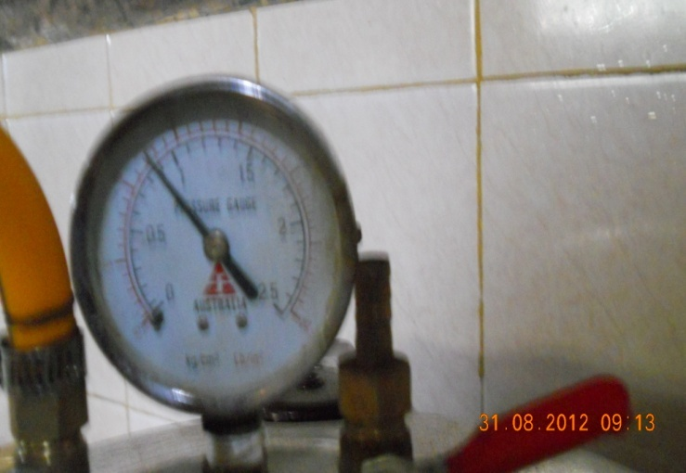

1. Pguage = 0,5 atm b. Pguage = 0,65 atm c. Pguage = 0,5 atm

**P = Pguage + 1 atm**

**Gambar 5**. *Presure guage*

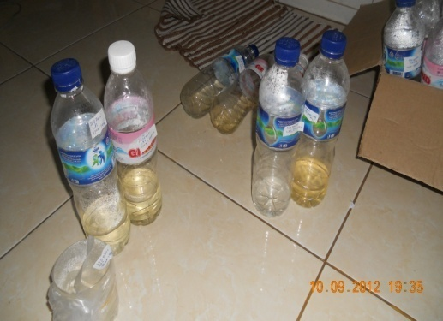 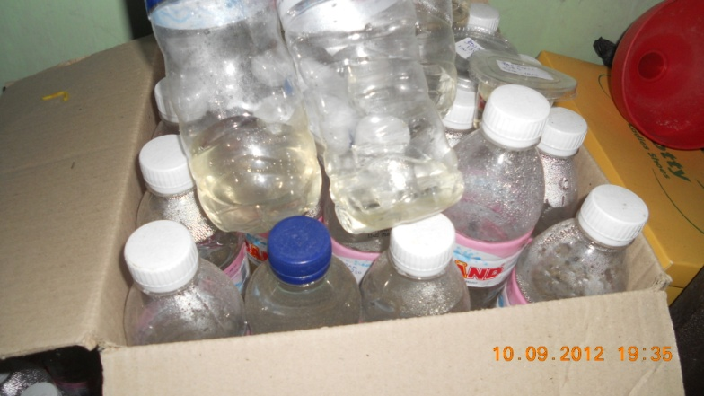

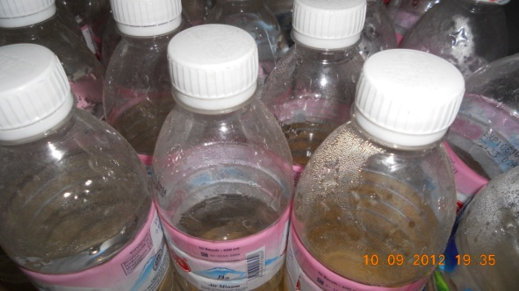 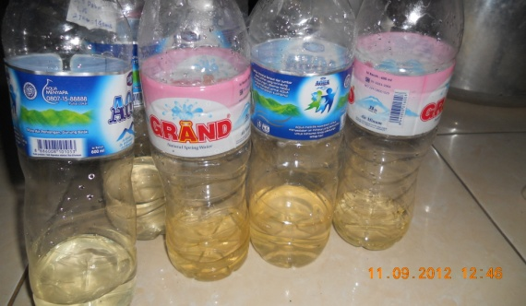

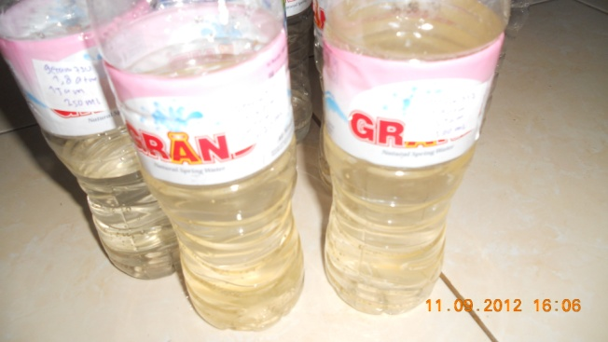

**Gambar 6**. Foto hasil penyulingan (air+minyak)

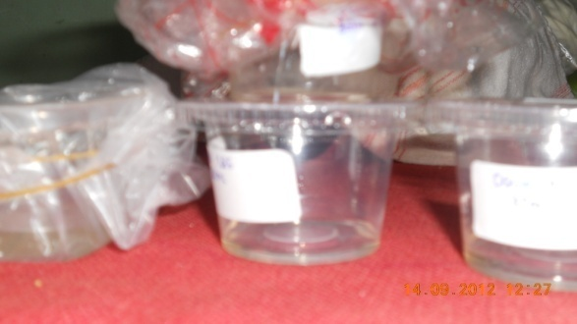 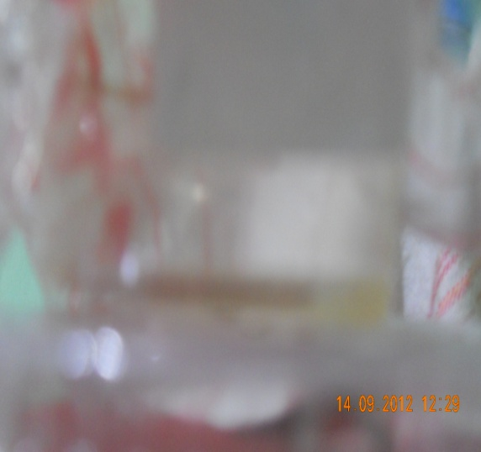

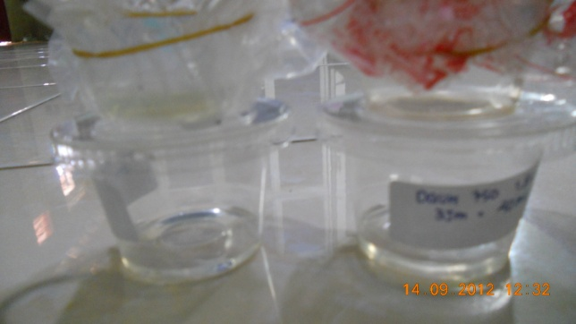 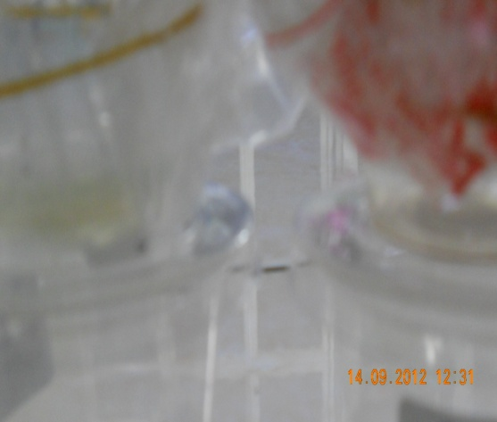

**Gambar 7**. Minyak atsiri (limbah daun, serbuk dan kikisan)

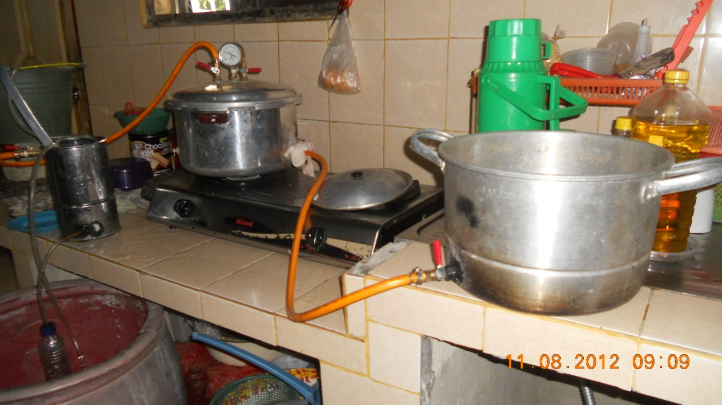

**Gambar 8**. Rangkaian alat pengujian